1. Demonstrate that you have copied script to turn EC2 into a web server (screenshot of Advanced Details section)

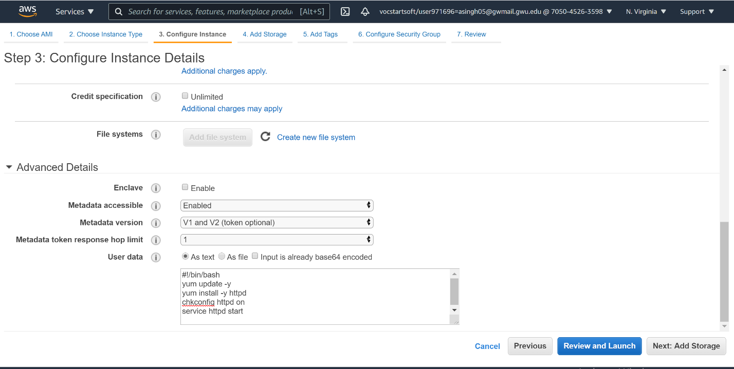

2. Demonstrate that you have opened HTTP port to My IP (screenshot of security group configuration)

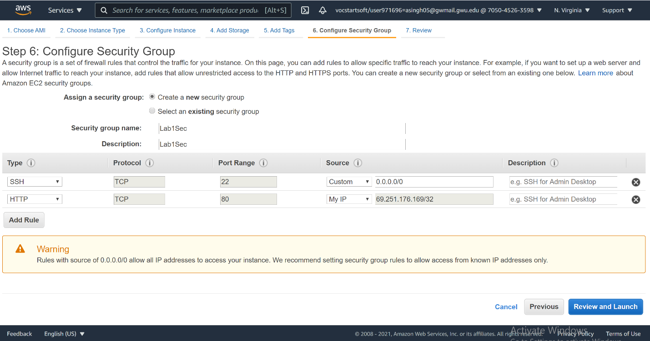

3. Demonstrate that you have running EC2 instance (Running status)

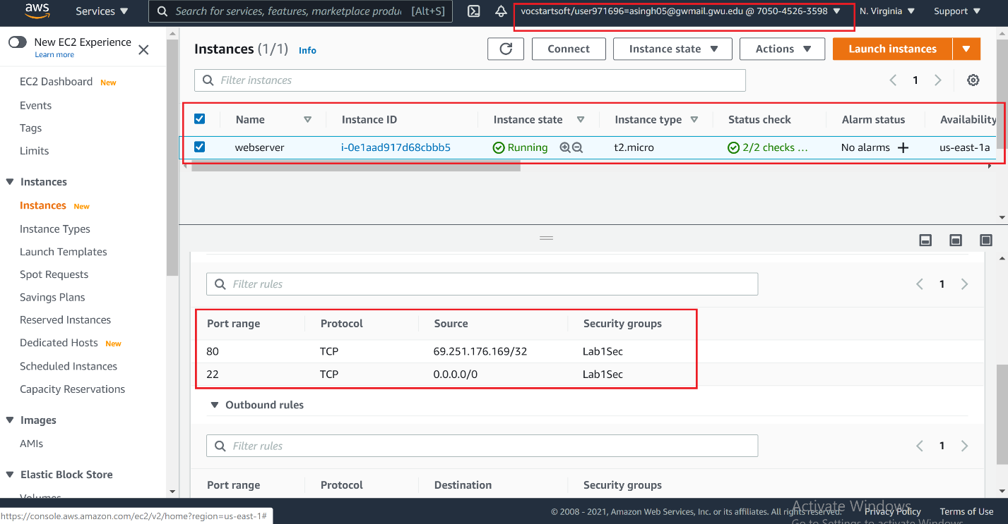

4. Demonstrate Apache Test Page

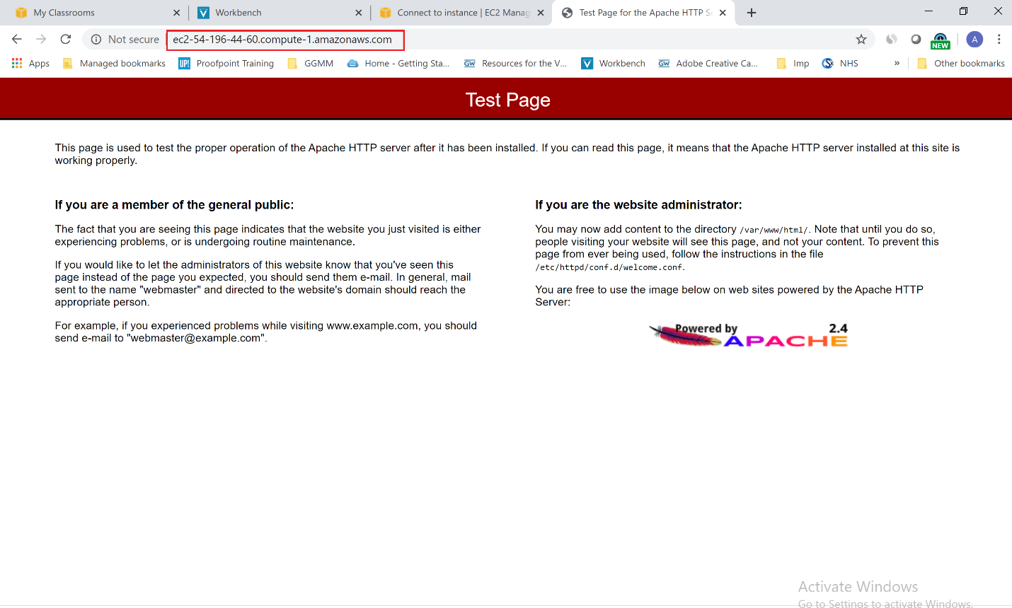

5. Show that you have connected to your instance (either via Terminal window or Putty)

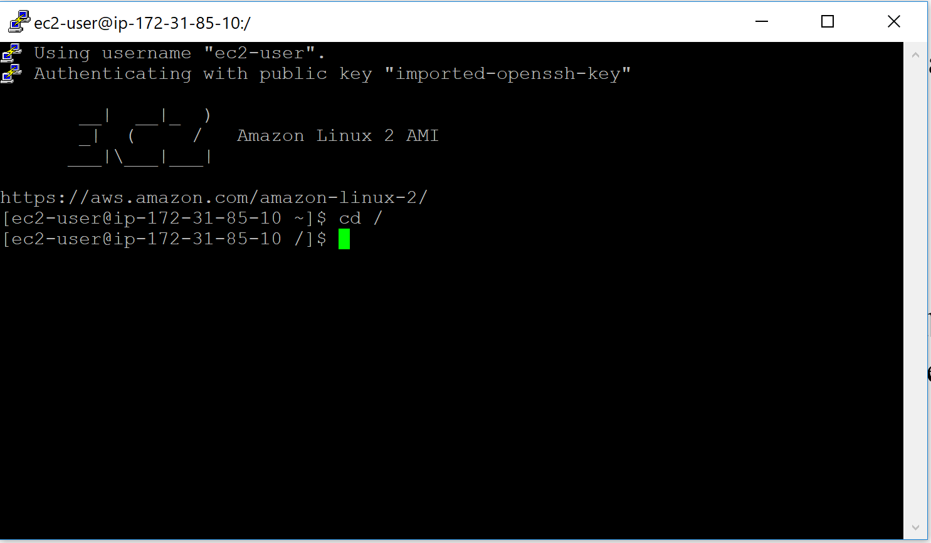

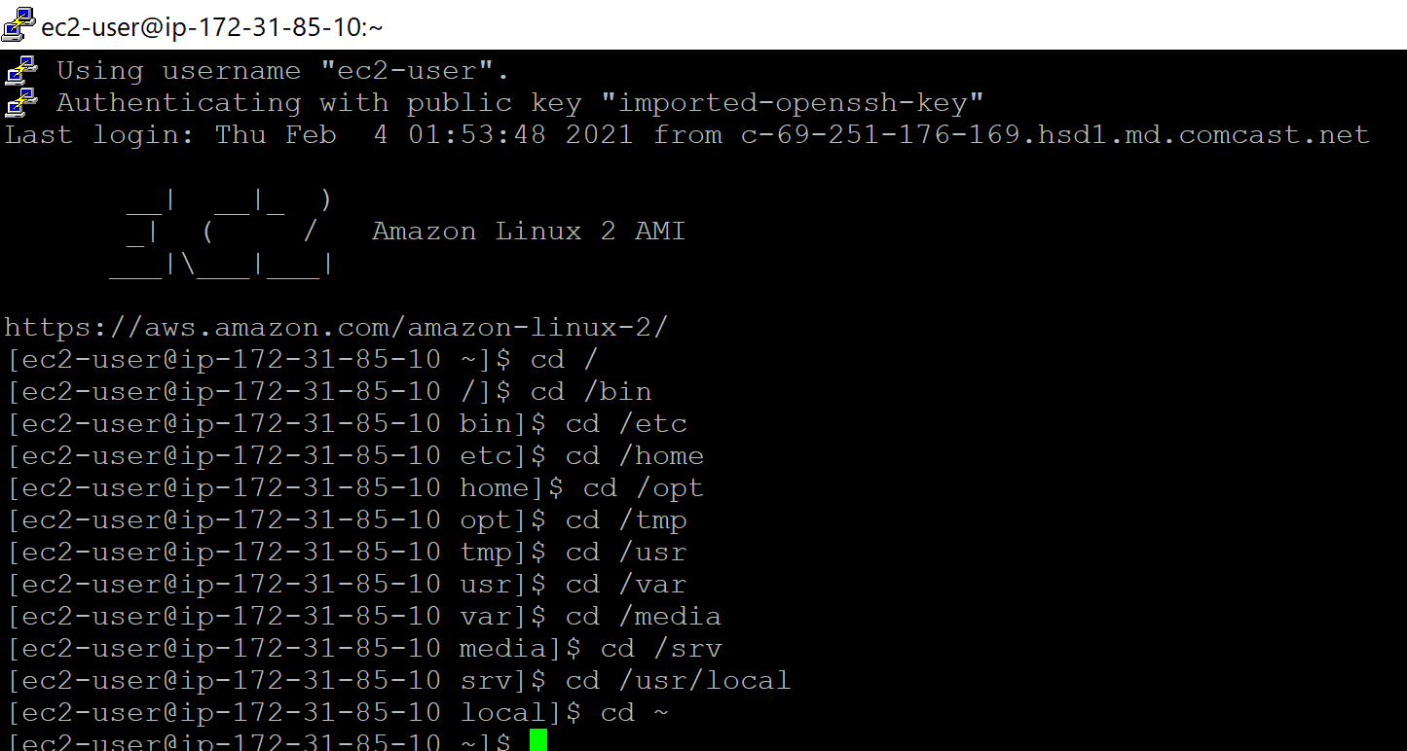

6. Screnshot of linuxtutorialwork directory that you created (Step 12 in Part III)

